摘要：在计算机网络中，通过一级级的协议之间的传输，能够将用户之间复杂的网络通信没有冲突地传输和表述。而在交通中，铁路、公路、物流、轨道等各个领域各自为营，相互独立，然而这些模块之间又相互关联、互联互通，共同组成复杂的交通网络。如何能通过学习复杂的计算机网络构建方法，用一个统一的网络形式来描述交通中的路网和流量关系，能够实现交通网络上的仿真和优化，是我们研究的目的。首先，阐述分层模型思想，文件准备原则等基本信息。其次，建立一个统一的路网准备文件数据，包括基本的路网信息，分为：node、link、agent。后续再添加字段属性。并给出这三个文件的准备示例，用户可以据此使用。最后，建立数学模型，用数学式子描述路网。

## Design methodology

### 1.1 计算机网络的系统结构分层方法

#### 1.1.1 网络协议

协议就是一组控制数据通信的规则，是实现某种功能的算法或程序，具体包括语义、语法和时序3个要素。

（1）语法。用于规定网络中所传输的数据和控制信息的结构组成或格式，如数据报文的格式，即对所表达内容的数据结构形式的一种规定，亦即“怎么讲”。

（2）语义。是指对构成协议的协议元素含义的解释，亦即“讲什么”。

（3）时序。是对事件执行顺序的详细说明。

#### 1.1.2 网络体系结构的分层模型

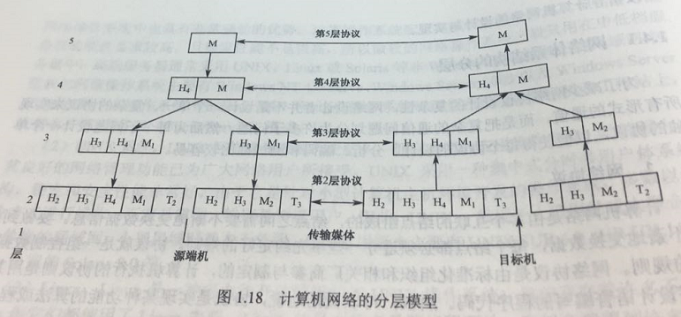

### 1.2 Layered network in transportation system

#### 1.2.1 Networking protocol

（1）Origin. Source of traffic flow in the traffic system.

（2）Road. Traveled from origin to destination.

（3）Destination. Sink of traffic flow in the traffic system.

#### 1.2.2 Transportation layered network modeling（simple）

There have three or more layers, including: （主要想把各个领域的问题，如何分层列出来）

|  |  |  |  |  |
| --- | --- | --- | --- | --- |
|  |  | Logistics |  |  |
| Activity zone: A layer | City A | Warehouse A |  |  |
| DTA Network: B layer | District B | Distribution center B |  |  |
| Cell simulation: C layer | Zone C | Site C |  |  |
|  | Corridors D |  |  |  |
|  |  |  |  |  |

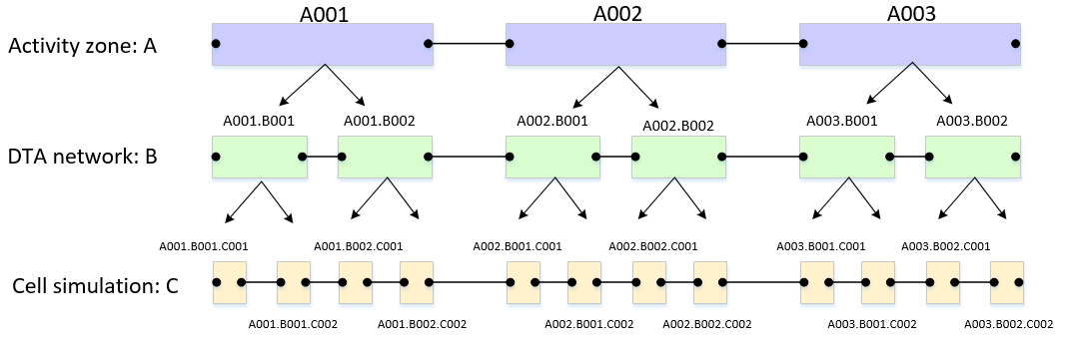

## File structure overview

We need at least three files, including node.csv, link.csv and agent.csv. And the specific properties of each file are shown below.

10001.SBL

10001.NBL

|  |  |  |  |  |
| --- | --- | --- | --- | --- |
| File Name | Address | Attributes | Observation data | Modeling MOE |
| node.csv | A001.B002 |  |  |  |
| link.csv | A001.B002 -> A001.B003 |  |  |  |
| agent.csv |  |  |  |  |

## Use cases

The unified layered network could be used in all areas of transportation.

|  |  |  |  |  |  |
| --- | --- | --- | --- | --- | --- |
| **User groups** | **Feature** | **Layer A** | **Layer B** | **Confidential** | **Users** |
| Freeway traffic engineering | traffic simulation, signal control | Main node/intersection | Modeling node | Pan |  |
| Network modeling | Traffic assignment |  |  | Zhu | Cheng, Huang |
| Activity based model | Interactions between layer A (zone) and layer B | Traffic analysis zone | Activity locations and physical network | Wu | Taehood |
| Microscopic simulation | Interactions between cars | Link | cell | Lu | Pan |
| Urban rail transit |  | Station | Modeling node | Shang |  |
| Railroad |  | Station | Modeling node | Meng and Miao | Zhang |
| Logistics |  | Distribution center | Modeling node | Niu | Meng |
| Network flow optimization | Standard assignment with side constraints  Max flow |  |  | Wu | Fu |
| VRP |  | Activity zones/depots | Activity location, Physical network | Yao | Zhang |

## Guiding principles for naming

0. we start with **csv** file system, then we will have **xml** file structure to store a large amount of data

1. File name, field name, all use lower case

2. hierarchical structure. Each file should have a field layer_type

3. Layer types: A, B… C. all use upper case characters

Numbers as ID:

Dot as separator

Guiding principles:

|  |  |  |
| --- | --- | --- |
| **Use case** |  |  |
| Organize sensor data | Code measurements |  |
| Map matching | Given coordinates | Derive network node/time sequence |
| NGSIM trajectory | Given local x y data | Plot space time trajectory |

## Examples

### input_node.csv

|  |  |  |  |  |  |
| --- | --- | --- | --- | --- | --- |
| node_id | layer_type | control_type | x | y | geometry |
| A001 | A |  |  |  |  |
| A001.B002 | B | 100 |  |  |  |
| A001.B002.C001 | C |  |  |  |  |

#### Notations：

|  |  |  |
| --- | --- | --- |
| **Field Name** | **Description** | **Sample Value** |
| node_id | Node identification number |  |
| address | Node address | A001.B002  Required |
| layer_type | which layer does the node belong to | A,B,C… |
| control_type | boundary nodes between clusters | 100 |
| x | Longitude or horizontal coordinate in any arbitrary geographic coordinate system. | 10000 |
| y | Latitude or vertical coordinate horizontal coordinate in any arbitrary geographic coordinate system | 20000 |
| geometry | Text string used to describe node location (typically in WGS84 geographic coordinate system) | <Point><coordinates>-111.979958,40.703899</coordinates></Point> |

### input_link.csv

|  |  |  |  |  |
| --- | --- | --- | --- | --- |
| link_id | layer_type | from_node_id | to_node_id | //Comments |
| string (user-defined) | B | A001.B002 | A002.B001 | Connectors |
| string (user-defined) | B | A001.B001 | A001.B002 | Internal cluster |

|  |  |  |  |  |  |  |
| --- | --- | --- | --- | --- | --- | --- |
| link_type | direction | length | speed_limit | cap | obs_q_t1 | obs_q_t2 |
|  |  |  |  |  |  |  |

#### Notations：

|  |  |  |
| --- | --- | --- |
| **Field Name** | **Description** | **Sample Values** |
| link_id | string (user-defined) | 101 |
| layer_type | which layer does the link belong to | B |
| from_node_id | Upstream node number of the link | Required |
| to_node_id | Downstream node number of the link | Required |
| from_address | Upstream node address of the link | Optional |
| to_address | Downstream node address of the link | Optional |
| direction |  |  |
| length | The length of the link (between end nodes), measured in units of miles. | 1.0 |
| speed_limit | Speed limit on defined link in units of miles per hour. Unit: mph | 60 |
| cap | Maximum service flow rate for each road for freeway; Maximum through capacity for railway; Maximum carrying capacity for logistics | 3000 |
| obs_q_t1 | at time stamp 1, with a user defined time interval, the flow observations | 160 |
| obs_Q_t2 | at time stamp 1, with a user defined time interval, queue length observations | 30 |
| q | Flow rate at each time interval (5 min) | 160 |
| k | Density at each time interval (5 min) | 1500 |
| v | Speed at each time interval (5 min) | 45 |
| TT | Travel time at each time interval (5 min) | 15 |
| Q | Queue length in each time interval (5 min) | 10 |
| Observations | Prefix | Obs |
| Simulation | Prefix | Sim |
| Estimation | Prefix | Est |
| Prediction | Prefix | Prd |
| est_TT_t0 |  |  |
| est_TT_t15 |  |  |

### input_agent.csv

|  |  |  |  |  |  |  |
| --- | --- | --- | --- | --- | --- | --- |
| agent_id | layer_type | agent_type | from_node_id | to_node_id | path_node_sequence | path_time_sequence |
| string (user-defined) | A |  | A001 | A010 |  | 11;12;13;14 |

#### Notations：

|  |  |  |
| --- | --- | --- |
| **Field Name** | **Description** | **Sample Values** |
| agent_id | string (user-defined) | 1 |
| layer_type | which layer does the link belong to | A |
| agent_type | agent type identification number | bus:1  car:2  … |
| from_node_id | Upstream node number of the link | A001.B001 |
| to_node_id | Downstream node number of the link | A002.B002 |
| path_node_sequence | The sequence node that through from origin node to destination node | A001.B001;A001.B002;A002.B001;A002.B002 |
| path_time_sequence | The sequence time that through from origin node to destination node at each internal node | 11;12;13;14 |
| path_global_xy_sequence |  |  |
| path_local_xy_sequence | Lane number as local x, horizonal distance as y | 0.1:0; 0.2:0; 0.3:0; 0.4:0;0.5:0 |
|  |  |  |

Examples

## Functions

Layered network for activity-based vehicle routing problem has three layers, namely, the activity network layer for passenger, the physical network for vehicle, and detailed routing network with time and state. In the activity network, each zone represents different function partition in the city, for example, the home, the office, and the shopping mall. The physical network includes the information of nodes and links, and the physical routes of vehicles are assigned in this layer. In the third layer, the space-time-state paths for passengers and vehicles are calculated and shown.

These three layers are coupled by the consistency constraints and consist a state-dependent and time-dependent multi-layer network.

### 6.1 Mapping functions between layers

(1) Flow on layer A = agent count on layer B

$$AX=\sum_{BX}{AX.BX}$$

(2) Avg travel time between nodes on layer A = avg travel time between nodes for all nodes layer B

$$AX=\sum_{BX}{AX.BX}$$

### 6.2 Consensus constraints